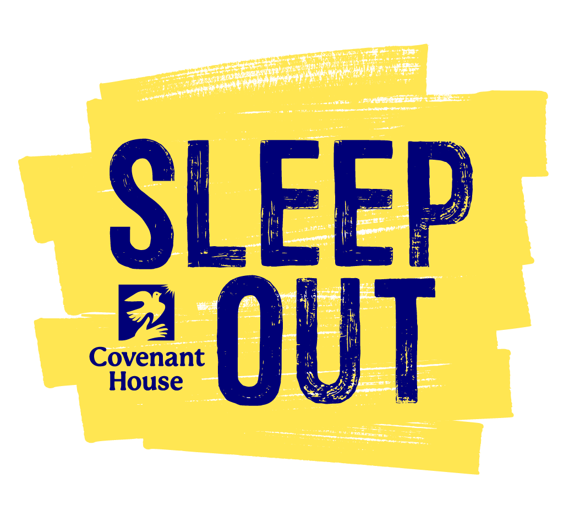

Welcome Kit

Thank you for signing up to Sleep Out: Chicago!
By giving up your bed for one night, you’re ensuring that youth facing homelessness can sleep safely at Covenant House Illinois. This Welcome Kit includes everything you need to make your Sleep Out experience meaningful.

Table of Contents
Page 1: About Covenant House Illinois & Sleep Out
Page 2: How to start fundraising.
Page 4: How to spread the word.
Page 5: Get Help!

Pssst: How to prepare for Sleep Out Chicago and live streaming information for virtual sleepers will be available on November 1st!

Quick Links

- Contact the Sleep Out:Chicago team lead: Meredith Oney (312)781-7554 | Money@covenanthouse.org

- Sleep Out Event Website: www.Sleepout.org/event/Chicago

- More information about Covenant House Illinois: https://www.covenanthouseil.org/

About Covenant House Illinois (CHIL) & Sleep Out
The young people who walk through the doors of Covenant House Illinois are our inspiration in everything we do. Hearing their stories is the best way to understand why we Sleep Out.

Read
- The Issues: read more on the factors that impact and drive youth homelessness.

- Continuum of Care: read about Covenant House International’s service model and the relentless support we offer young people at every step of their journey from homelessness to self-sufficiency.

- Newsroom: find the most up-to-date stories about youth and work being done at Covenant House sites across North America.

- Read about CHIL Youth & other success stories here!

- View CHIL News & Updates here

Watch

- 2022 Sleep Out: Chicago video: https://www.youtube.com/watch?v=uWT_Dz28cKQ&t=1s

- Watch our CHIL youth video here (don’t skip this one!)

- Watch a virtual tour of CHIL’s new campus here!

- SHELTER documentary (recommended for viewers ages 16+)

Connect
- Keep up with Covenant House Illinois on social media:

  - Facebook: https://www.facebook.com/CovenantHouseIL/
  - Instagram: https://www.instagram.com/covenanthouseil/?hl=en
  - Twitter: https://twitter.com/CovenantHouseIL
  - LinkedIn: https://www.linkedin.com/company/22313011/admin/

  - Hashtags: #CovenantHouseIL #CHIL #SleepOutChicago #endyouthhomelessness

How to start fundraising.
Every dollar you raise through Sleep Out helps Covenant House provide a safe shelter, critical services, and hope for a brighter future for young people overcoming homelessness.

Fundraising Checklist

Step 1: Log in to your personal fundraising page by going to www.SleepOut.org/event/Chicago and clicking the icon in the upper right corner of the page. Enter your email address and password.

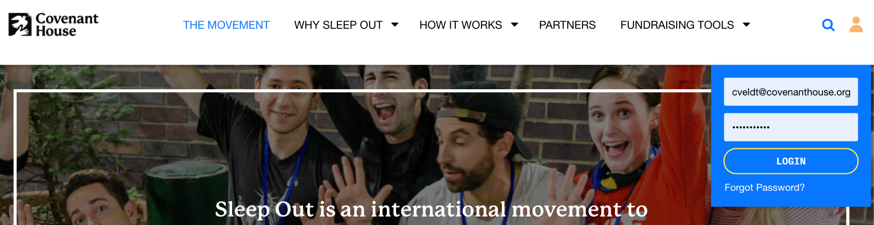

Step 2: Once you’re logged in, click the “Your Page” or “Team Page” icon. Scroll down to find pencil icons that you can click to update your fundraising goal, photo, or story of why you joined Sleep Out.
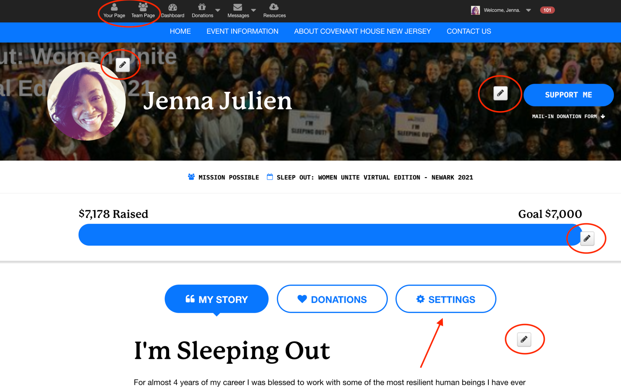

Step 3: Click the “Settings” tab (next to “My Story” and your donation list on your fundraising page) and scroll down to customize your page link. This link is what you will share with friends and family so they can donate directly to your Sleep Out page.

This is also where you can adjust the privacy settings of your page and link a Facebook Fundraiser with your Sleep Out page.

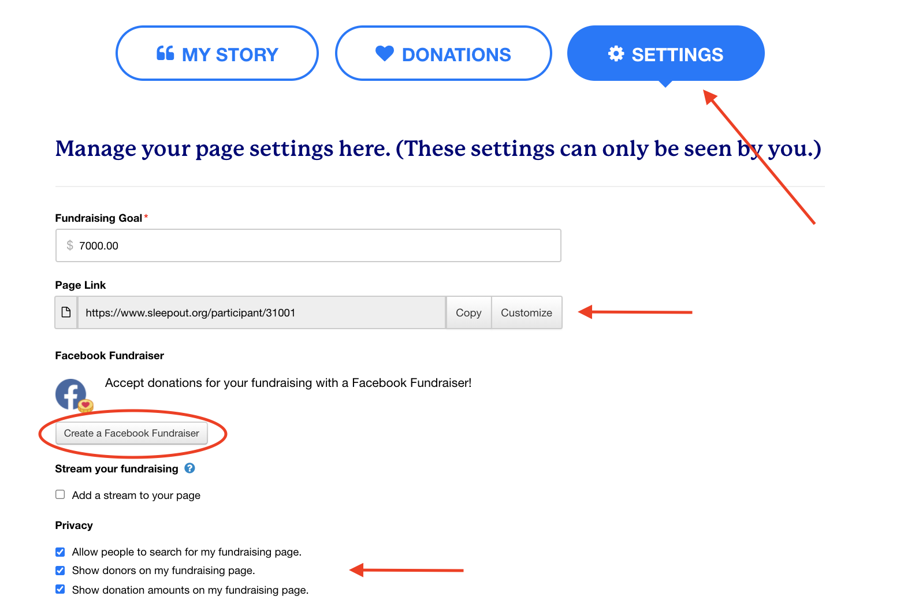

How to spread the word.
Sleep Out is a grassroots, peer-to-peer fundraiser. By spreading the word, you can make people aware of the youth homelessness crisis and what we can do to help.

Spread the Word Checklist

Step 1: Make a list of 10-50 people who you want to email, text, or call with an invitation to join or support your Sleep Out. Consider the following questions when making your list:

- Would this person open an email from me?
- Would I want to hear from them about something they’re passionate about?
- Is this a cause that they could connect with?
- Is this an appropriate time to reach out? (e.g. has this person been especially affected by the pandemic?)

Step 2: Visit sleepout.org/fundraise to find sample messages, shareable content, and information about Covenant House and youth homelessness. Use these resources to compose a message to your friends and family about Sleep Out and why you need their support. Then hit send!

OR click the “Messages” icon in your participant dashboard to send emails directly from your Sleep Out account. Select a sample message using the “Compose Message” feature and follow the prompts to import your contact list and send your message.

OR look through this Dropbox folder for graphics and materials that you can share on social media.

Step 3: Follow up! Believe it or not, most people need 2-3 reminders before they register or make a donation. Use email, text, phone calls, and in-person conversations to follow up with friends and family.

Social media is another great way to remind people about your Sleep Out. Set a goal of posting 1-2 times per week. Keep it interesting by shaking up your messages and the types of content that you post (e.g. video links, photos, graphics, and statistics).

Find shareable content at sleepout.org/content and in this Dropbox folder.

Step 4: Say thank you. As people respond to your appeals, thank them! (And do it publicly!) Tag your team members and donors in an appreciation post on social media, send a message of thanks to a group chat,
or reply-all on an email thread to recognize their contributions.

Find a list of your donors by clicking the “Donations” icon in your participant dashboard. Find sample thank you messages at sleepout.org/sample-messages
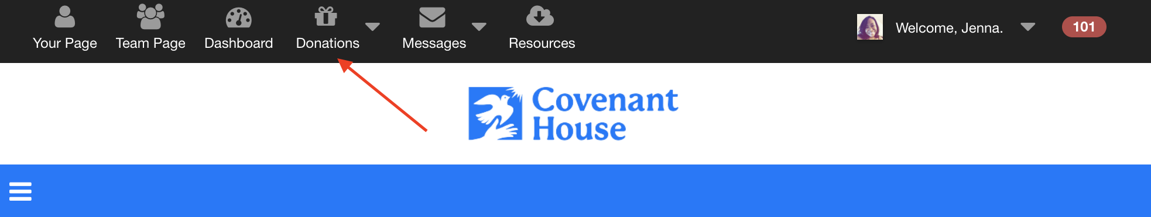

Coming Soon: Frequently Asked Questions & Livestreaming information for Sleep Out Chicago will be available November 1st

Get Help!
Our team is here to help! Don’t hesitate to reach out to us with any questions.

Meredith Oney
Call: 312-781-7554
Email: money@covenanthouse.org
Website: www.sleepout.org/event/chicago

